EXP-2
Bus Ticket Booking Prototype (Figma)
Aim
To design a simple Bus Ticket Booking System prototype using Figma.
Procedure
- Open Figma and create a new design file.
- Design screens:
- Home Page
- Search Bus
- Seat Selection
- Payment Page
- Add navigation links.
- Present prototype mode.

Output
Output 1 – Bus Search / Results Screen
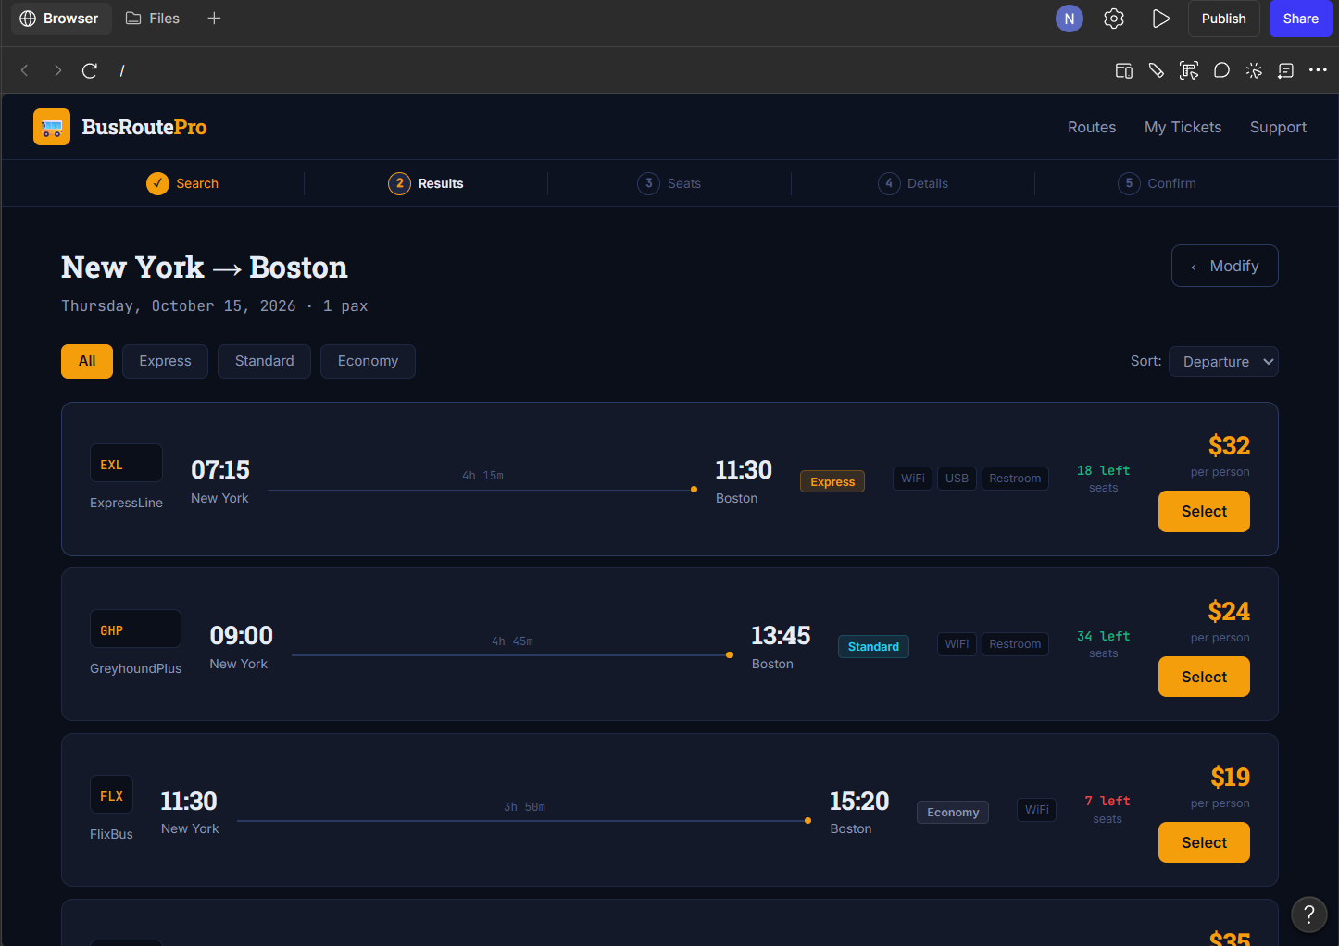

Output 2 – Seat Selection Screen
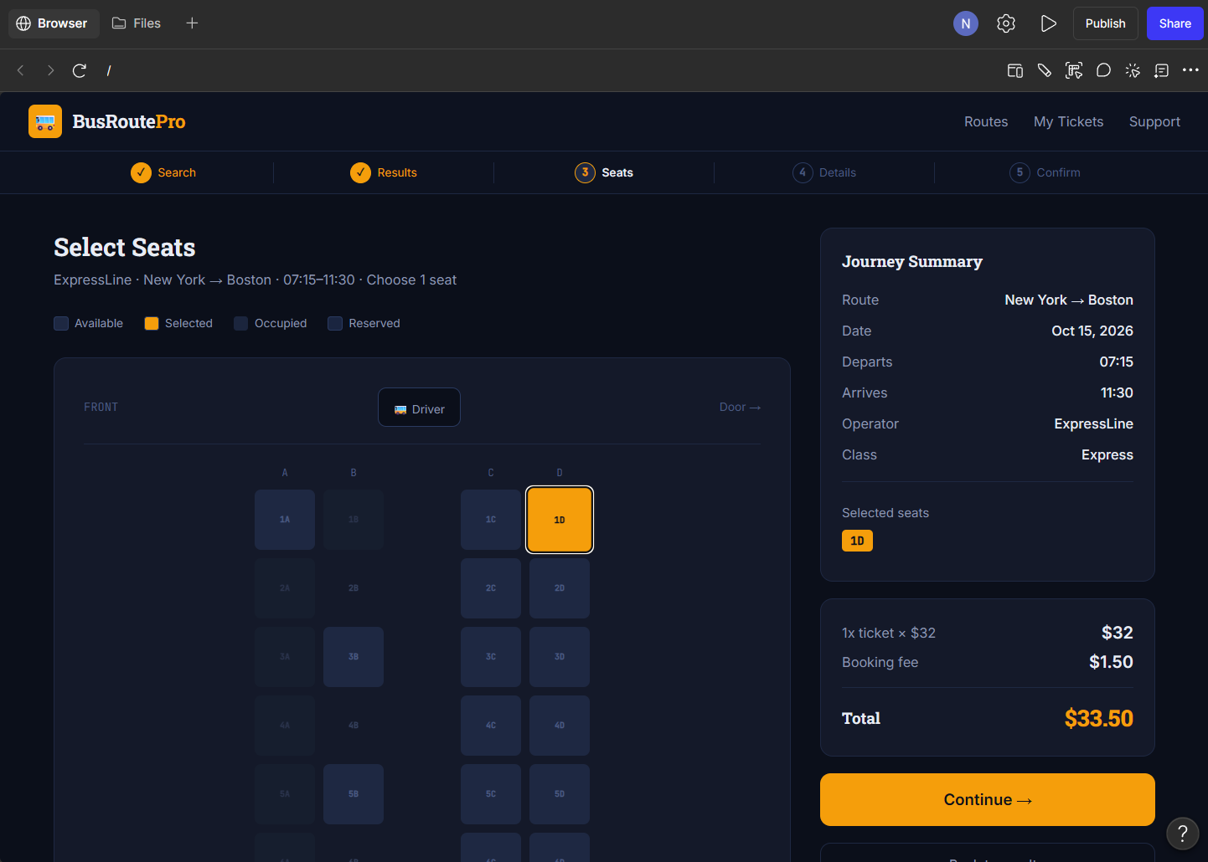

Output 3 – Passenger Details Screen
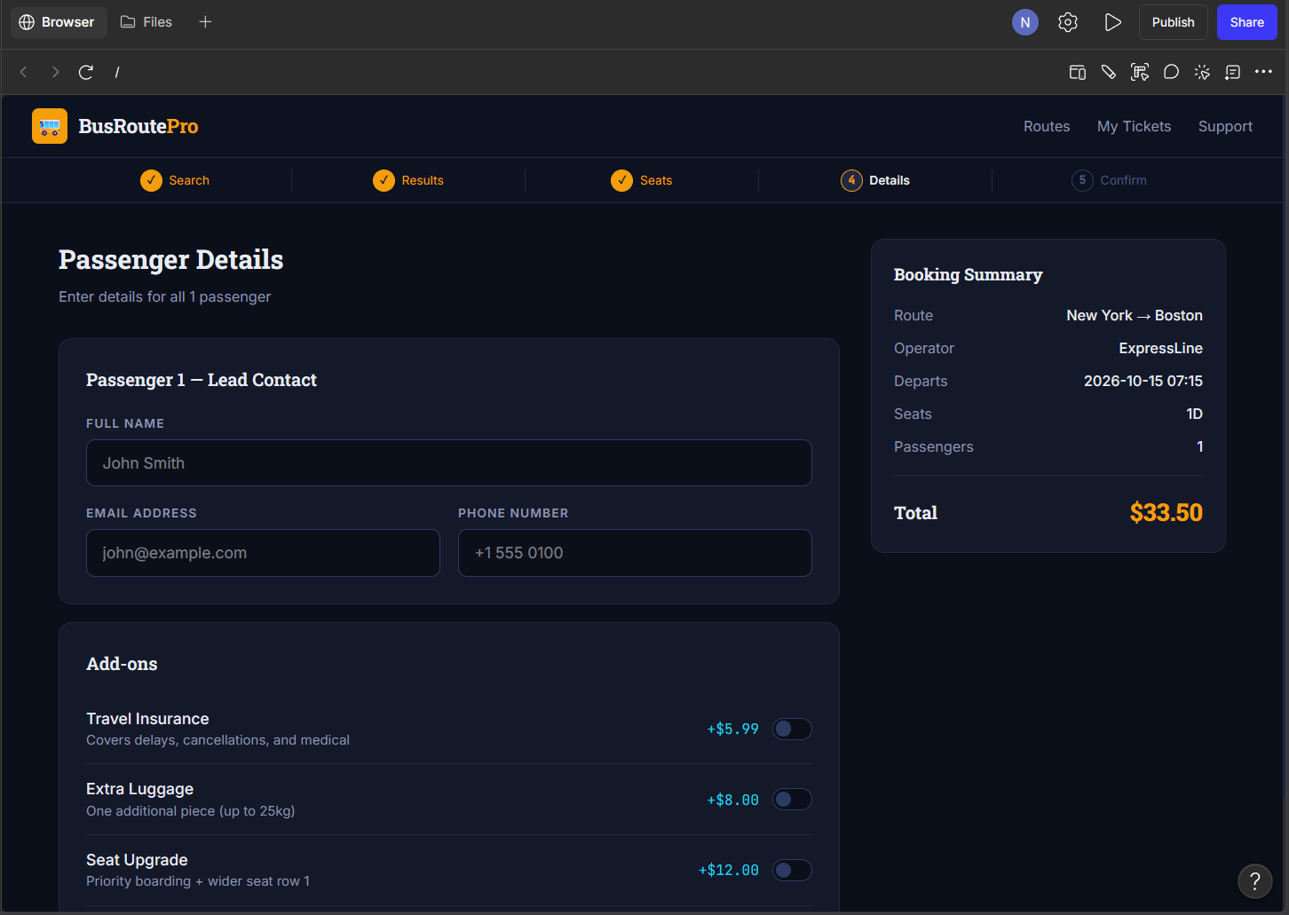

Output 4 – Booking Confirmation Screen
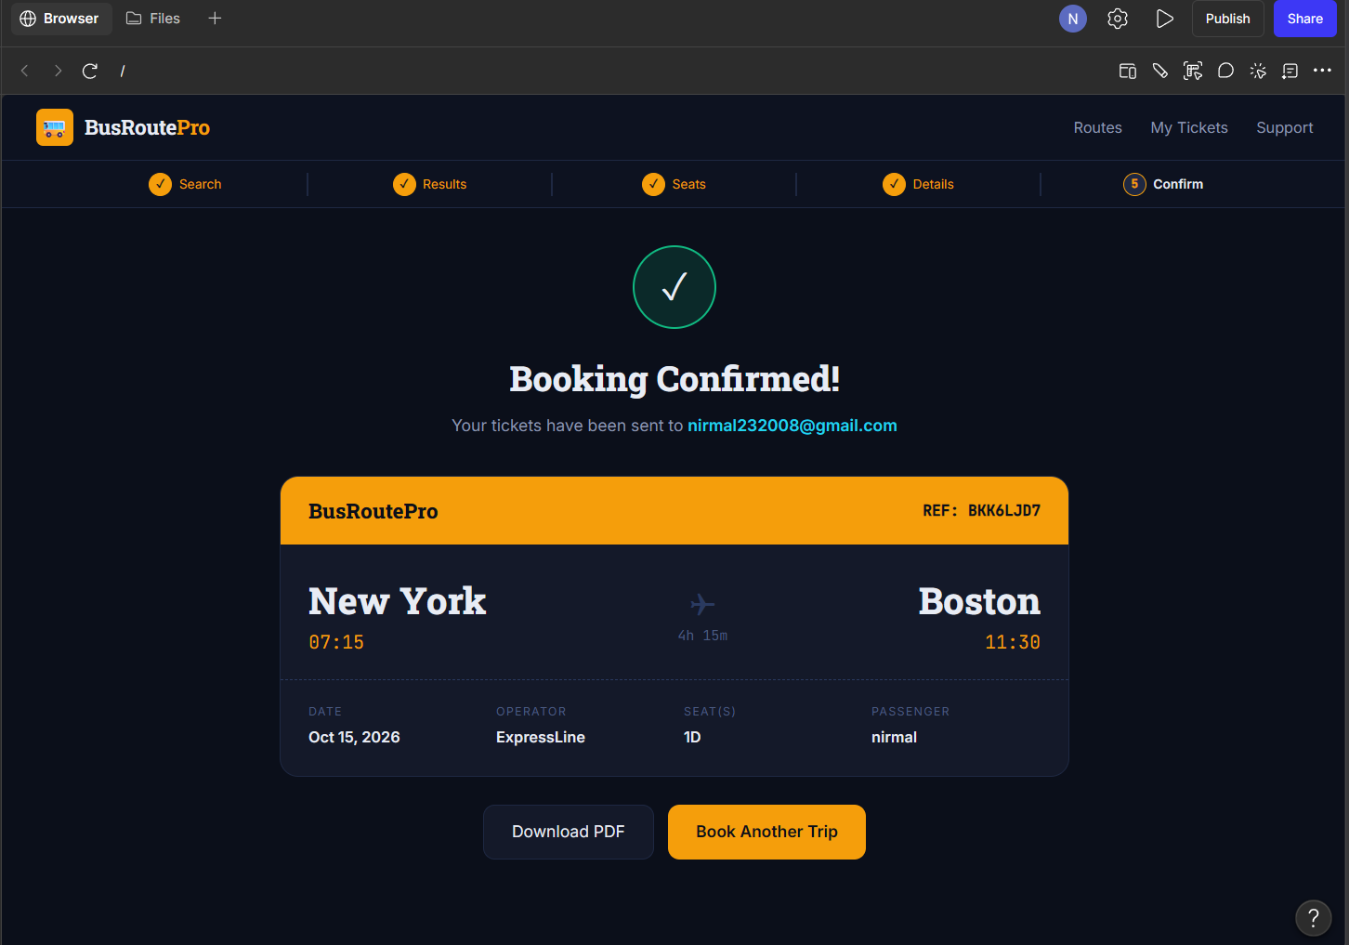

Result
Thus, a simple Bus Ticket Booking System prototype was successfully designed and demonstrated in Figma. The prototype includes the bus search, seat selection, passenger details, and booking confirmation screens with navigation between the screens.

